6/16/2021

**Computer Organization**

**FINAL LAB EXAM-REPORT**

**AMINA QADEER-359607**

**CE-42-A**

**CO-FINAL LAB EXAM**

**SUBMITTED TO MA’AM RIMSHA TARIQ**

**QUESTION:**

**COMPILED MIPS ASSEMBLY CODE:**

.data

X: .space 80

Y: .space 80

Message1: .asciiz "Enter any 20 numbers for x_array "

Message2: .asciiz "Enter any 20 numbers for y_array"

Space: .asciiz " "

.text

li $t0, 0

#Printing a message1 on screen

li $v0, 4

la $a0, Message1

syscall

while:

bgt $t0, 80, terminate

#Taking input from the user

li $v0, 5

syscall

#taking input for x

sw $v0, X($t0)

addi $t0, $t0, 4

j while

terminate:

li $t0, 0

#Printing a message2 on screen

li $v0, 4

la $a0, Message2

syscall

while2:

bgt $t0, 80, terminate2

#Taking input from the user

li $v0, 5

syscall

#taking input for y

sw $v0, Y($t0)

addi $t0, $t0, 4

j while2

terminate2:

#setting registers to 0

li $t0, 0

li $t2, 0

li $t3, 0

li $t4, 0

li $t6, 0

while3:

bgt $t0, 80, terminate3

lw $t9, X($t0)

lw $t8, Y($t0)

#multiply sigma x and y for numerator

mult $t8, $t9

mflo $t7

#sigmaxy for numerator

add $t2, $t2, $t7

add $t3, $t3, $t9

add $t4, $t4, $t8

#x^2

mult $t9, $t9

mflo $t5

#sigmax^2

add $t6, $t6, $t5

li $v0, 1

move $a0, $t2

syscall

addi $t0, $t0, 4

j while3

terminate3:

mult $t3, $t4

mflo $t9

#sigma x.sigmy/n

li $s0, 20

div $t9, $s0

mflo $t9

#sigmaxy -(sigma x.sigmy/n) #numerator complete

sub $t9, $t2, $t9

#(sigmax)^2

mult $t3, $t3

mflo $t8

#(sigmax)^2/n

div $t8, $s0

mflo $t8

#sigmax^2-((sigmax)^2/n)#denominator

sub $t8, $t6, $t8

#b1

div $t9, $t8

mflo $t7

#for index11

li $t0, 44

lw $t1, X($t0)

lw $t2, Y($t0)

#multiply b1 and x[11]

mult $t7, $t1

mflo $t3

#b0=y[11]-b1

sub $t6, $t2, $t3

#b1x

mult $t7,$t1

mflo $t7

#y=b0+b1x

add $t5,$t6,$t7

li $v0, 10

syscall

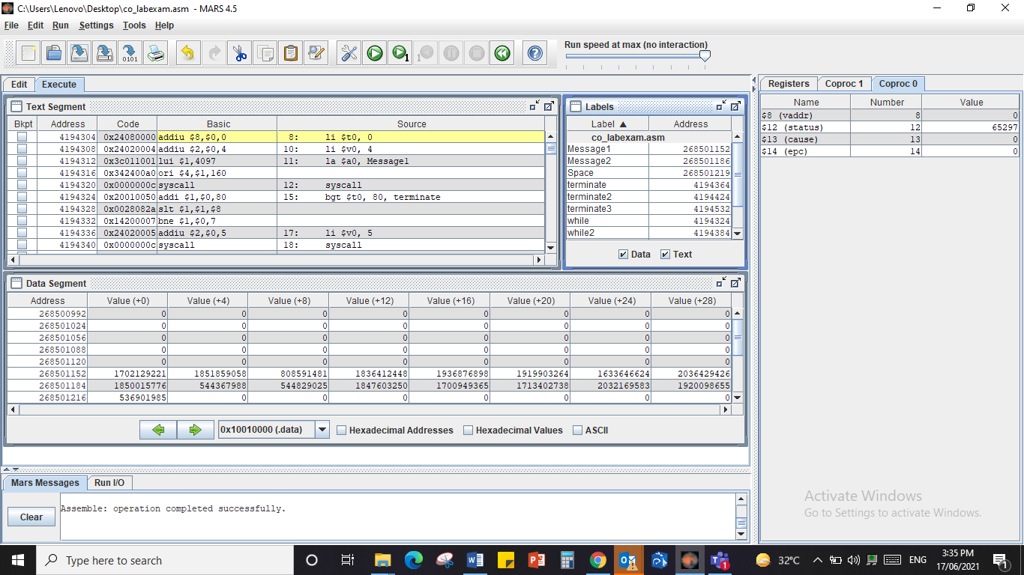

Enter any 20 numbers for x_array 2  
2  
2  
2  
2  
2  
2  
2  
2  
2  
2  
2  
2  
2  
2  
2  
2  
2  
2  
2  
Enter any 20 numbers for y_array3  
3  
3  
3  
3  
3  
3  
3  
3  
3  
3  
3  
3  
3  
3  
3  
3  
3  
3  
3  
6121824303642485460667278849096102108114123  
-- program is finished running --

